FOR IMMEDIATE RELEASE: 4/29/2019
Krista Brown
Gifted Support Network
636-344-0036
info@giftedsupportnetwork.org

GIFTED SUPPORT NETWORK MAKES A TEACHER’S WISH A REALITY
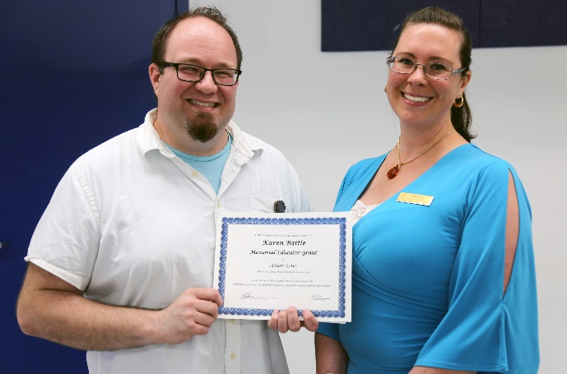
Educator Grants Fund Projects for Gifted & Talented Students

Left to Right: Adam Estes; Krista Brown, GSN Program Coordinator

Wentzville, MO: Six teachers from various districts around Metro St. Louis were chosen to receive the Karen Battle Memorial Educator Grant from local nonprofit organization, Gifted Support Network. Teachers from across the St. Louis area submitted applications to fund various projects for their gifted and talented students to encourage creative and collaborative thinking, and keep them challenged academically.
Adam Estes from Wentzville Middle School was presented with funds to encourage service learning with his students using a book called “Me to We”. Adam shares, “For me, the most important goal these funds will help meet is not a curricular one at all - it's simply to encourage students to engage in their world and make a difference however they can. This also ties in with our curricular goal of demonstrating good citizenship, specifically our sub-goal of recognizing and responding to the needs of others.” Adam’s goal is to provide many practical steps for students to engage in projects that will make a difference in their community, and the additional supplies he will purchase will allow them to fully interact with the contents of the book.
Gifted Support Network is a nonprofit organization that aims to provide high-quality, low-cost resources to gifted educators and families of gifted children. Karen Battle Memorial Educator Grants are made possible by private and public donations and are awarded annually in the month of March. If you are interested in making a contribution to help continue making these grants possible, please visit our website: www.giftedsupportnetwork.org and click “Donate”.
###

