FOR IMMEDIATE RELEASE: 4/29/2019
Krista Brown
Gifted Support Network
636-344-0036
info@giftedsupportnetwork.org

GIFTED SUPPORT NETWORK MAKES TWO HAZELWOOD TEACHERS’ WISHES A REALITY
Educator Grants Fund Projects for Gifted & Talented Students

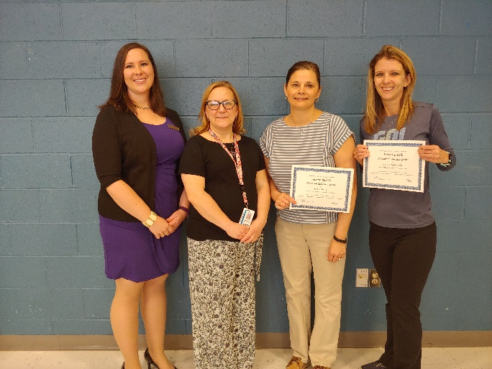
Hazelwood, MO: Two teachers Hazelwood School District’s GALACTIC Program were chosen to receive the Karen Battle Memorial Educator Grant from local nonprofit organization, Gifted Support Network. Teachers from across the St. Louis area submitted applications to fund various projects for their gifted and talented students to encourage creative and collaborative thinking, and keep them challenged academically.
Kasey Healy received a grant award to purchase Ozobots, which are small robots used to teach various aspects of coding. Kasey explains, “Our goal is to think and work like engineers when creating codes for the Ozobots. We will define a problem and design a solution. We will also be able to test our designs, collect and analyze data, and then revise our designs based on evidence.”
Carrie Ziolkowski, also a GALACTIC program teacher, received a funds for her “Read, Right, Run” class. Carrie shares, “My students have impressive goals and big hearts, and they are creative, critical thinkers who collaborate.” This class challenges students to be active, boost their reading skills and do good to others around them.
Left to Right: Krista Brown, GSN Program Coordinator; Tracy Bednarick, Gifted Ed Coordinator for HSD; Kasey Healy; Carrie Ziolkowski
Gifted Support Network is a nonprofit organization that aims to provide high-quality, low-cost resources to gifted educators and families of gifted children. Karen Battle Memorial Educator Grants are made possible by private and public donations and are awarded annually in the month of March. If you are interested in making a contribution to help continue making these grants possible, please visit our website: www.giftedsupportnetwork.org and click “Donate”.

###

