FOR IMMEDIATE RELEASE: 4/29/2019
Krista Brown
Gifted Support Network
636-344-0036
info@giftedsupportnetwork.org

GIFTED SUPPORT NETWORK MAKES TWO TEACHERS’ WISHES A REALITY
Educator Grants Fund Projects for Gifted & Talented Students
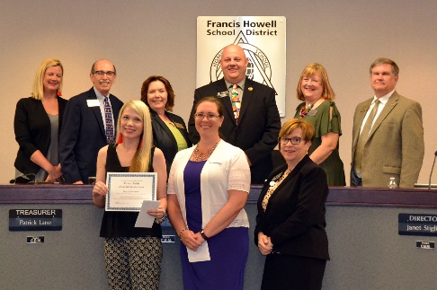
Saint Peters, MO: Six teachers from various districts around Metro St. Louis were chosen to receive the Karen Battle Memorial Educator Grant from local nonprofit organization, Gifted Support Network. Teachers from across the St. Louis area submitted applications to fund various projects for their gifted and talented students to encourage creative and collaborative thinking, and keep them challenged academically.
Tracy Branstetter is a 4th and 5th grade teacher for the SEGA Program in Francis Howell School District. SEGA stands for “Students with Exceptional Gifted Abilities” and is a self-contained gifted program for the top 1% of students in the district, housed at Castlio Elementary School. “One of the biggest struggles I face with teaching students with exceptional gifted abilities in a classroom setting is having enough high-quality literature books to meet their needs. Our students are expected to read and discuss advanced-level literature books in literature circles on a weekly basis. Some of these books reach beyond the level of what is offered at an elementary level.” Tracy’s grant award will help her provide both challenging and appropriate reading and discussion material in her classroom, which will also be shared with other teachers and students at Castlio.
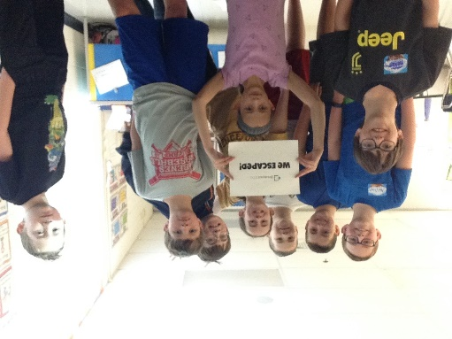
Maggie Henke is also an educator in Francis Howell, and teaches at Independence Elementary School. She received a grant to purchase a Breakout EDU kit – a challenging breakout box that includes online access for students to develop their own games and challenges using the kit. Maggie explains, “The Breakout EDU Kit is simple to implement but powerful in having students engaged in their learning. They work together with critical and creative thinking skills and have to persevere in order to open locks to solve the challenge.” Collaborating with like-minded peers and developing patience are important skills for any students, but especially for high-achieving students, as they often struggle with a high degree of perfectionism.
Ms. Henke’s students are enjoying the Breakout EDU Kit!
Gifted Support Network is a local nonprofit organization that aims to provide high-quality, low-cost resources to gifted educators and families of gifted children. Karen Battle Memorial Educator Grants are made possible by private and public donations and are awarded annually in the month of March. If you are interested in making a contribution to help continue making these grants possible, please visit our website: www.giftedsupportnetwork.org and click “Donate”.
###

